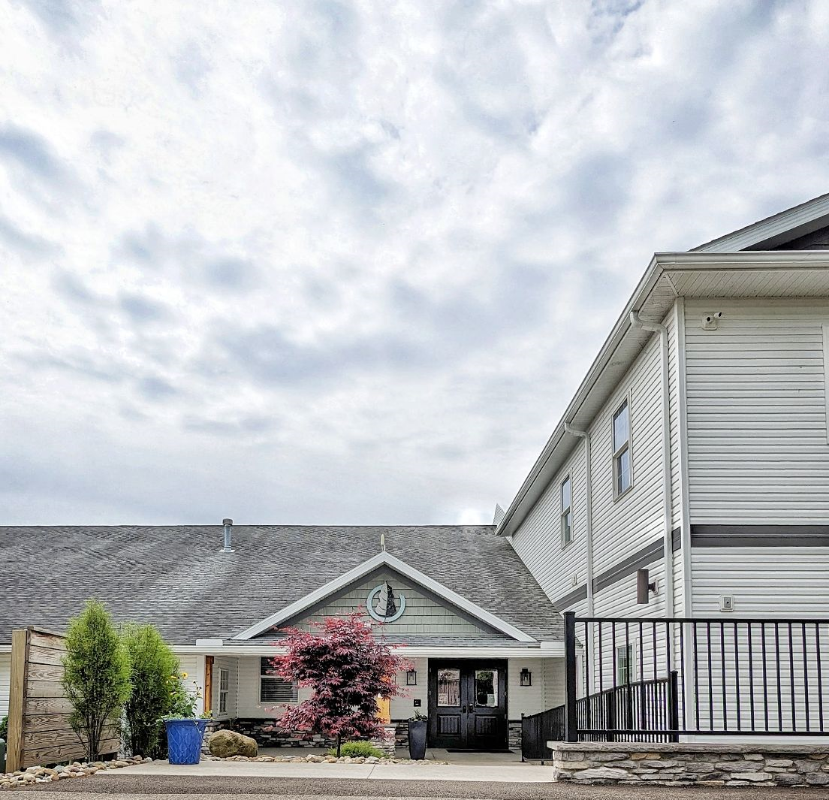
SpringHaven & Woodside Rest
Fundraising project

- Finish second floor for additional office space at the Mt. Eaton office
- Since the previous expansion we have increased services to the community by 20%.
- More people are asking for help than ever before.
- All our offices are filled, and more space is needed to hire more therapists.

- Purchase 15-acre woods and land adjacent to our Mt. Eaton office
- Land was purchased by members of the community to transfer to SpringHaven/Woodside Rest.
- We currently use the woods and pavilion for outdoor
counseling sessions.
- This land positions us for future growth and
development.

Total estimated cost of the campaign is $1.038 million.
Includes: $398,000 for finishing the 2nd floor.
$640,000 for land purchase.

Please consider supporting this campaign and our mission of leading people toward wholeness!

hhhhhhhhhhhhdd

